AccessionIndex: TCD-SCSS-T.20150217.003
Accession Date: 17-Feb-2015
Accession By: Dr.Brian Coghlan
Object name: Prototype RAID
Vintage: c.1990
Synopsis: First RAID chassis built in the Dept.Computer Science, TCD, with five SCSI-1 disks and PC/AT power supply. PSU S/N: 7X705993.

Description:
This system was the first RAID chassis built in the Dept.Computer Science, TCD, a precursor to embarking on the design and construction of the Stable Disk, see elsewhere in the collection. This proved to be an excellent and effective learning exercise.

The RAID prototype was deliberately simple, comprising five Fujitsu 330MB SCSI-1 disks connected via ribbon cable to a SCSI controller within a PC. The current PSU is a standard PC/AT power supply, but is not the original PSU.

The five disks were on the same SCSI bus, so the disk commands and data were communicated sequentially. The SCSI controller (an old and basic ISA bus adapter) included driver software in EPROM, and after this was disassembled and understood, a simple assembly-language program was used to test RAID 0, 1, 3, and 5 operations. These were really only functional tests in order to better understand the RAID principles.

This RAID was subsequently used as shared storage for the first Beowulf cluster constructed in the department, and directly influenced the design of shared storage for the next two generations of clusters. For each of these, see elsewhere in the collection.

The homepage for this catalog is at: https://www.scss.tcd.ie/SCSSTreasuresCatalog/
Click 'Accession Index' (1st column listed) for related folder, or 'About' for further guidance. Some of the items below may be more properly part of other categories of this catalog, but are listed here for convenience.

Accession Index | Object with Identification
TCD-SCSS-T.20150217.003.01 | Prototype RAID, First RAID chassis built in the Dept.Computer Science, TCD, with five SCSI-1 disks and PC/AT power supply. PSU S/N: 7X705993, c.1990.
TCD-SCSS-T.20150217.003.02 | SCSI Disk Chassis 1.  Chassis S/N:  Disk S/N:
TCD-SCSS-T.20150217.003.03 | SCSI Disk Chassis 2.  Chassis S/N:  Disk S/N:
TCD-SCSS-T.20150217.003.04 | SCSI Disk Chassis 3.  Chassis S/N:  Disk S/N:
TCD-SCSS-T.20150217.003.05 | SCSI Disk Chassis 4.  Chassis S/N:  Disk S/N:
TCD-SCSS-T.20150217.003.06 | SCSI Disk Chassis 5.  Chassis S/N:  Disk S/N:
TCD-SCSS-T.20150217.003.07 | Mitsubishi PC20WA PSU.  S/N: 7X705993
TCD-SCSS-T.20121208.096 | Tolsys Stable Disk Controller, First Irish-designed fault-tolerant disk controller, TSMR2006 RAID Controller, TSMV2004 Stable Memory, multiwire technology, intended to control 35 SCSI-2 drives, designed and constructed by campus company spun out of Dept.Computer Science, c.1992.
TCD-SCSS-T.20121208.094 | Experimental SCSI Cluster, 4-node prototype cluster using SCSI as interconnect, 1997.
TCD-SCSS-T.20121208.095 | csTCDie Beowulf Cluster, Departmental cluster using 100Mbps Ethernet as interconnect, c.199x.
TCD-SCSS-T.20141120.003 | csTCDie Grid-Ireland SCI Cluster, 16-node cluster using 400MB/s SCI switched interconnect, c.1999.

References

- Wikipedia, “RAID”, see: https://en.wikipedia.org/wiki/RAID

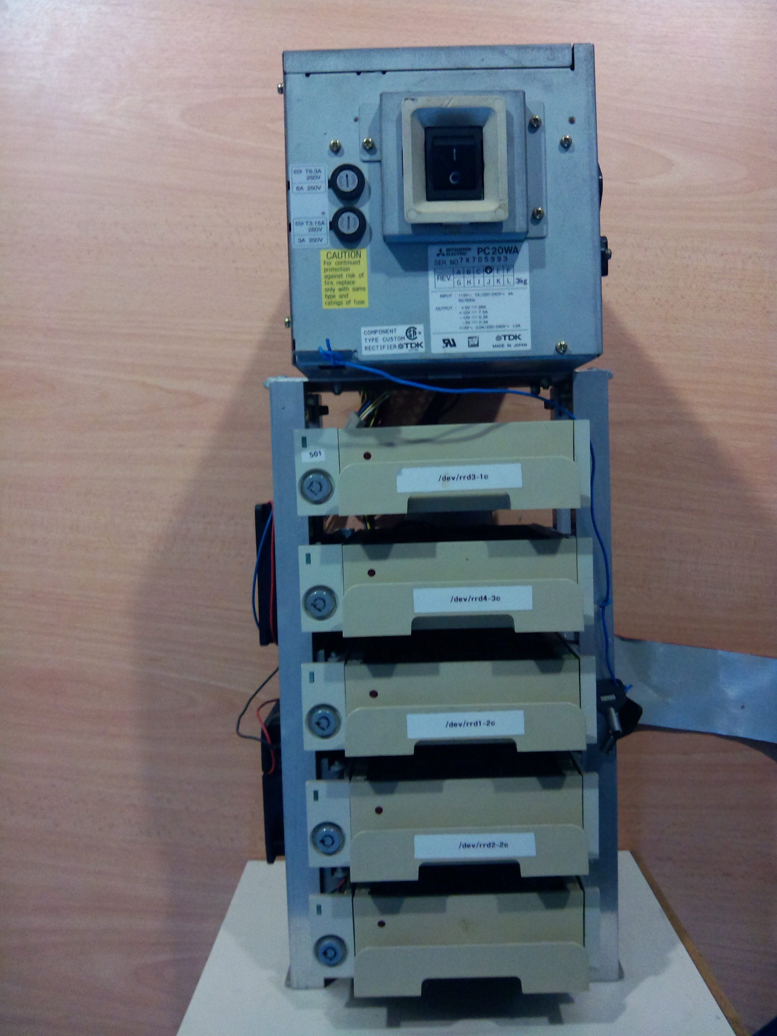
Figure 1: Prototype RAID front view
Mitsubishi PC20WA PSU S/N: 7X705993

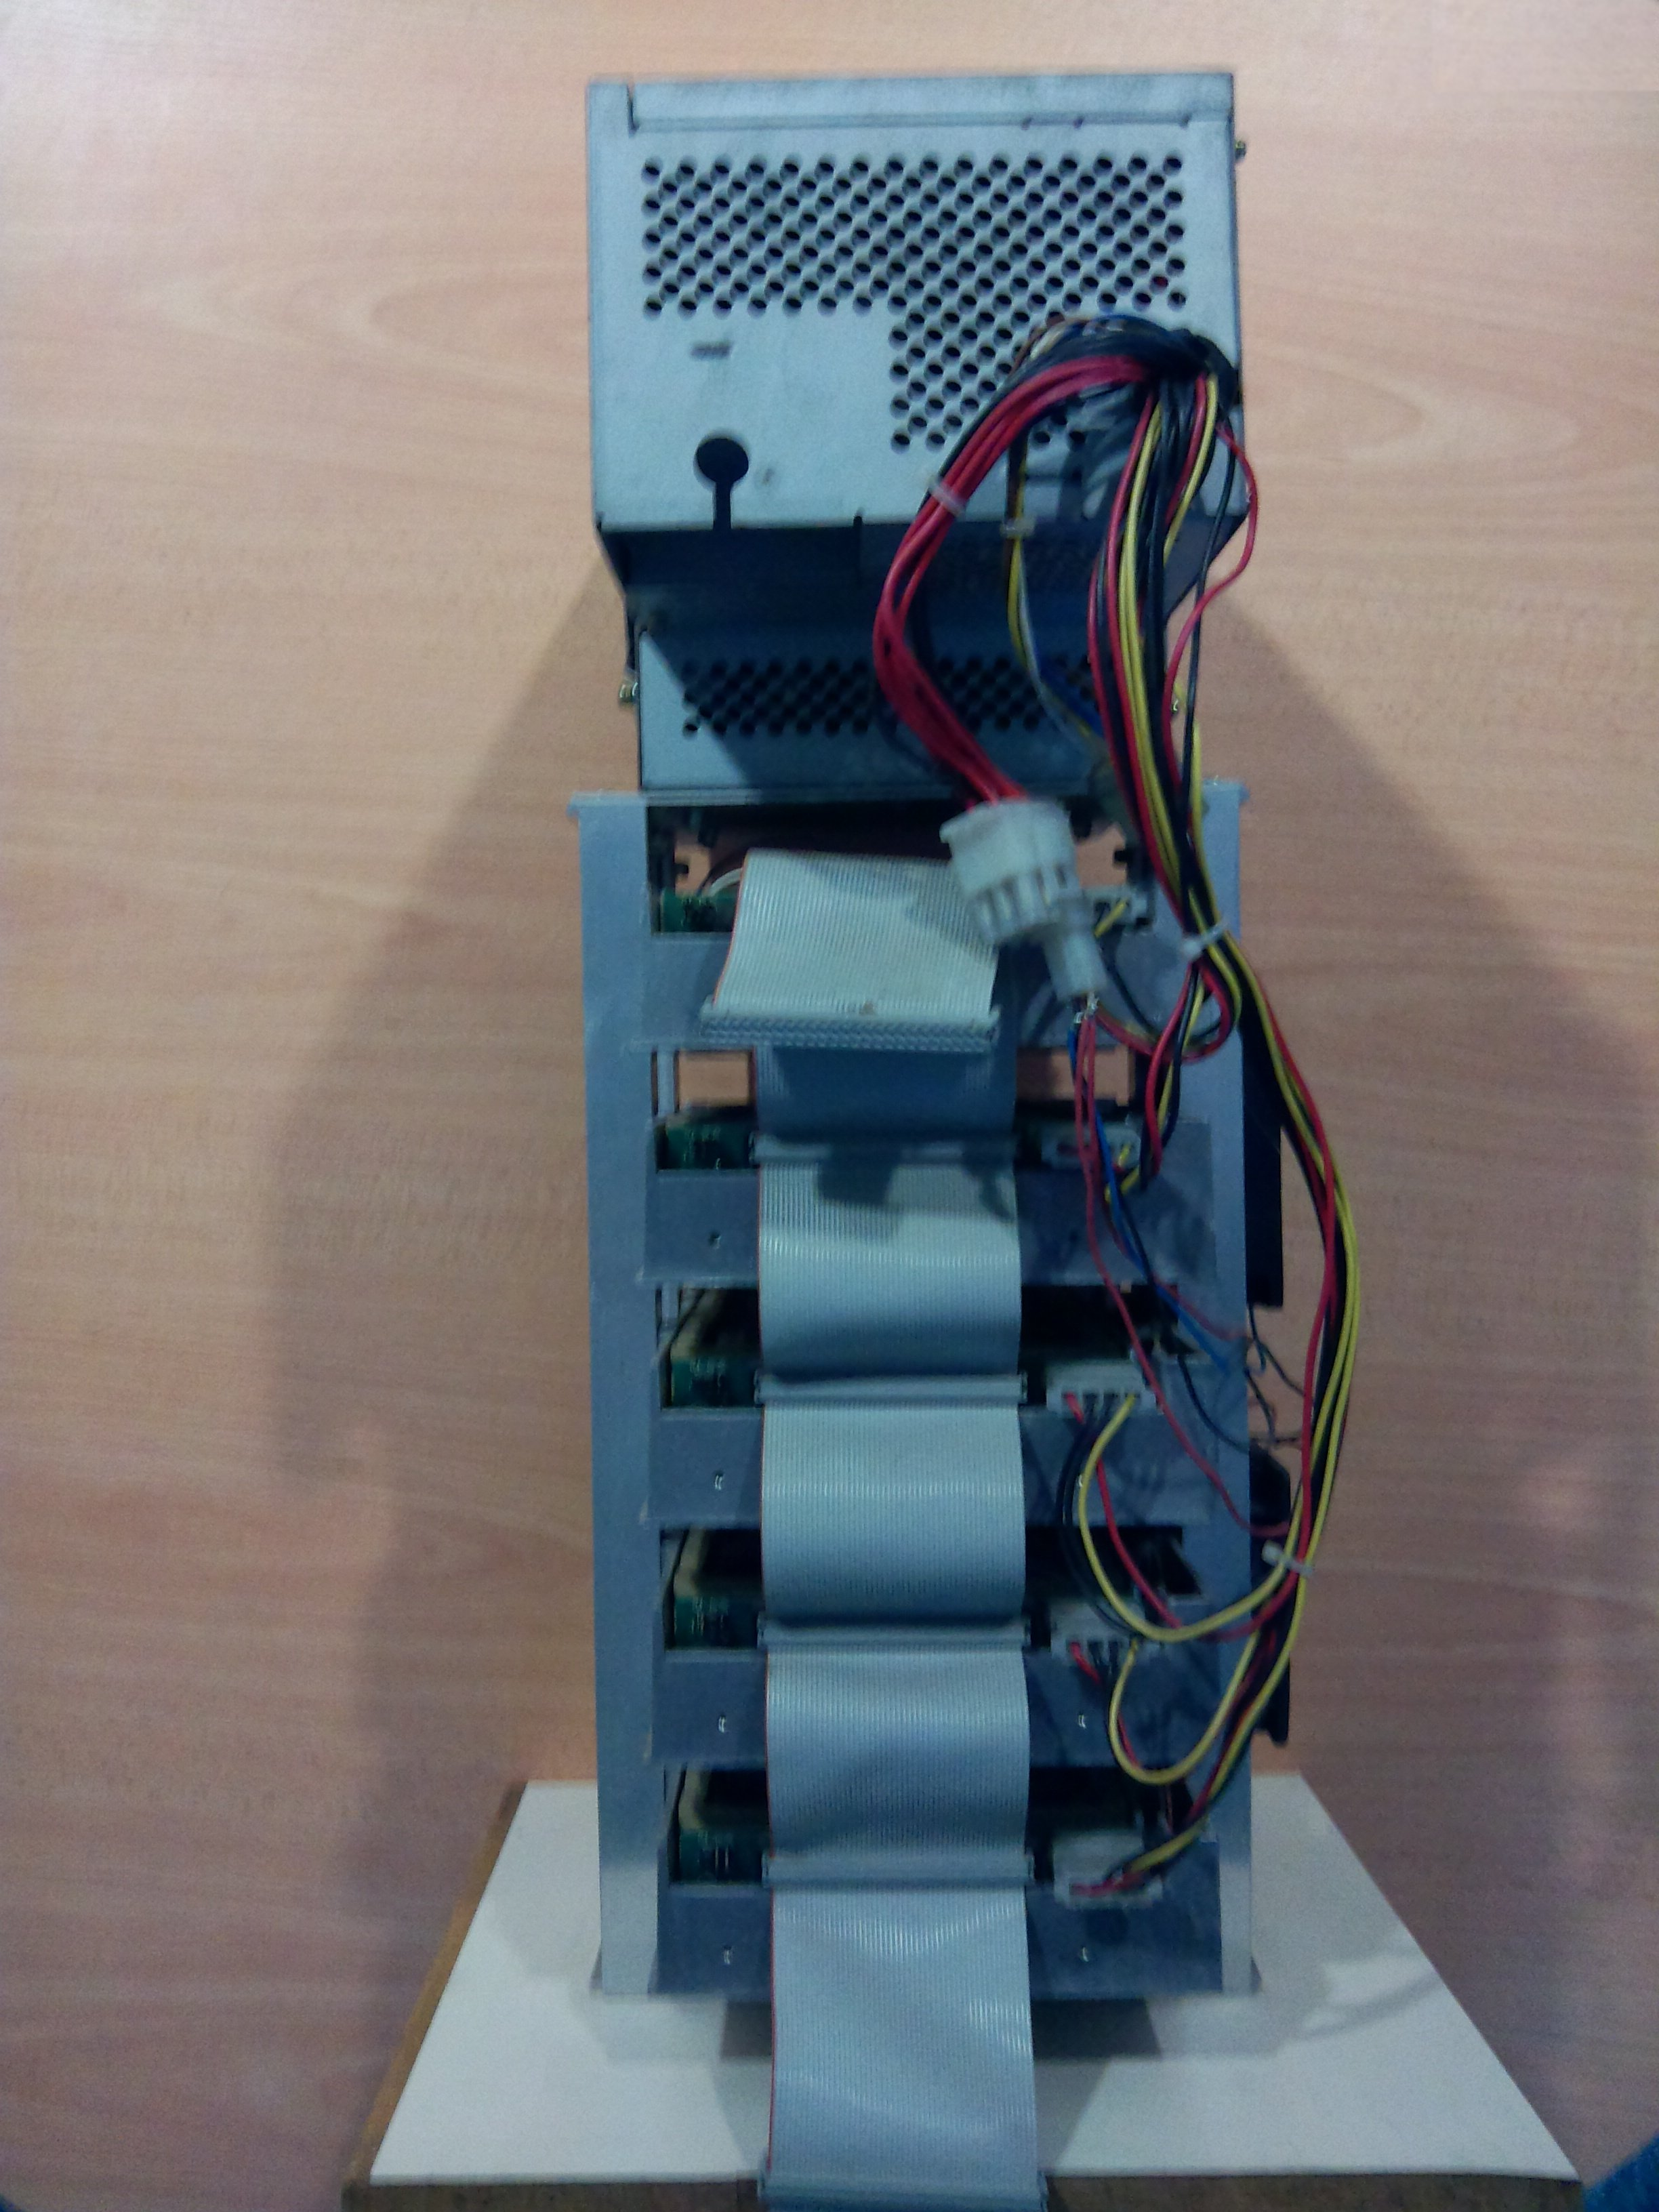
Figure 2: Prototype RAID rear view

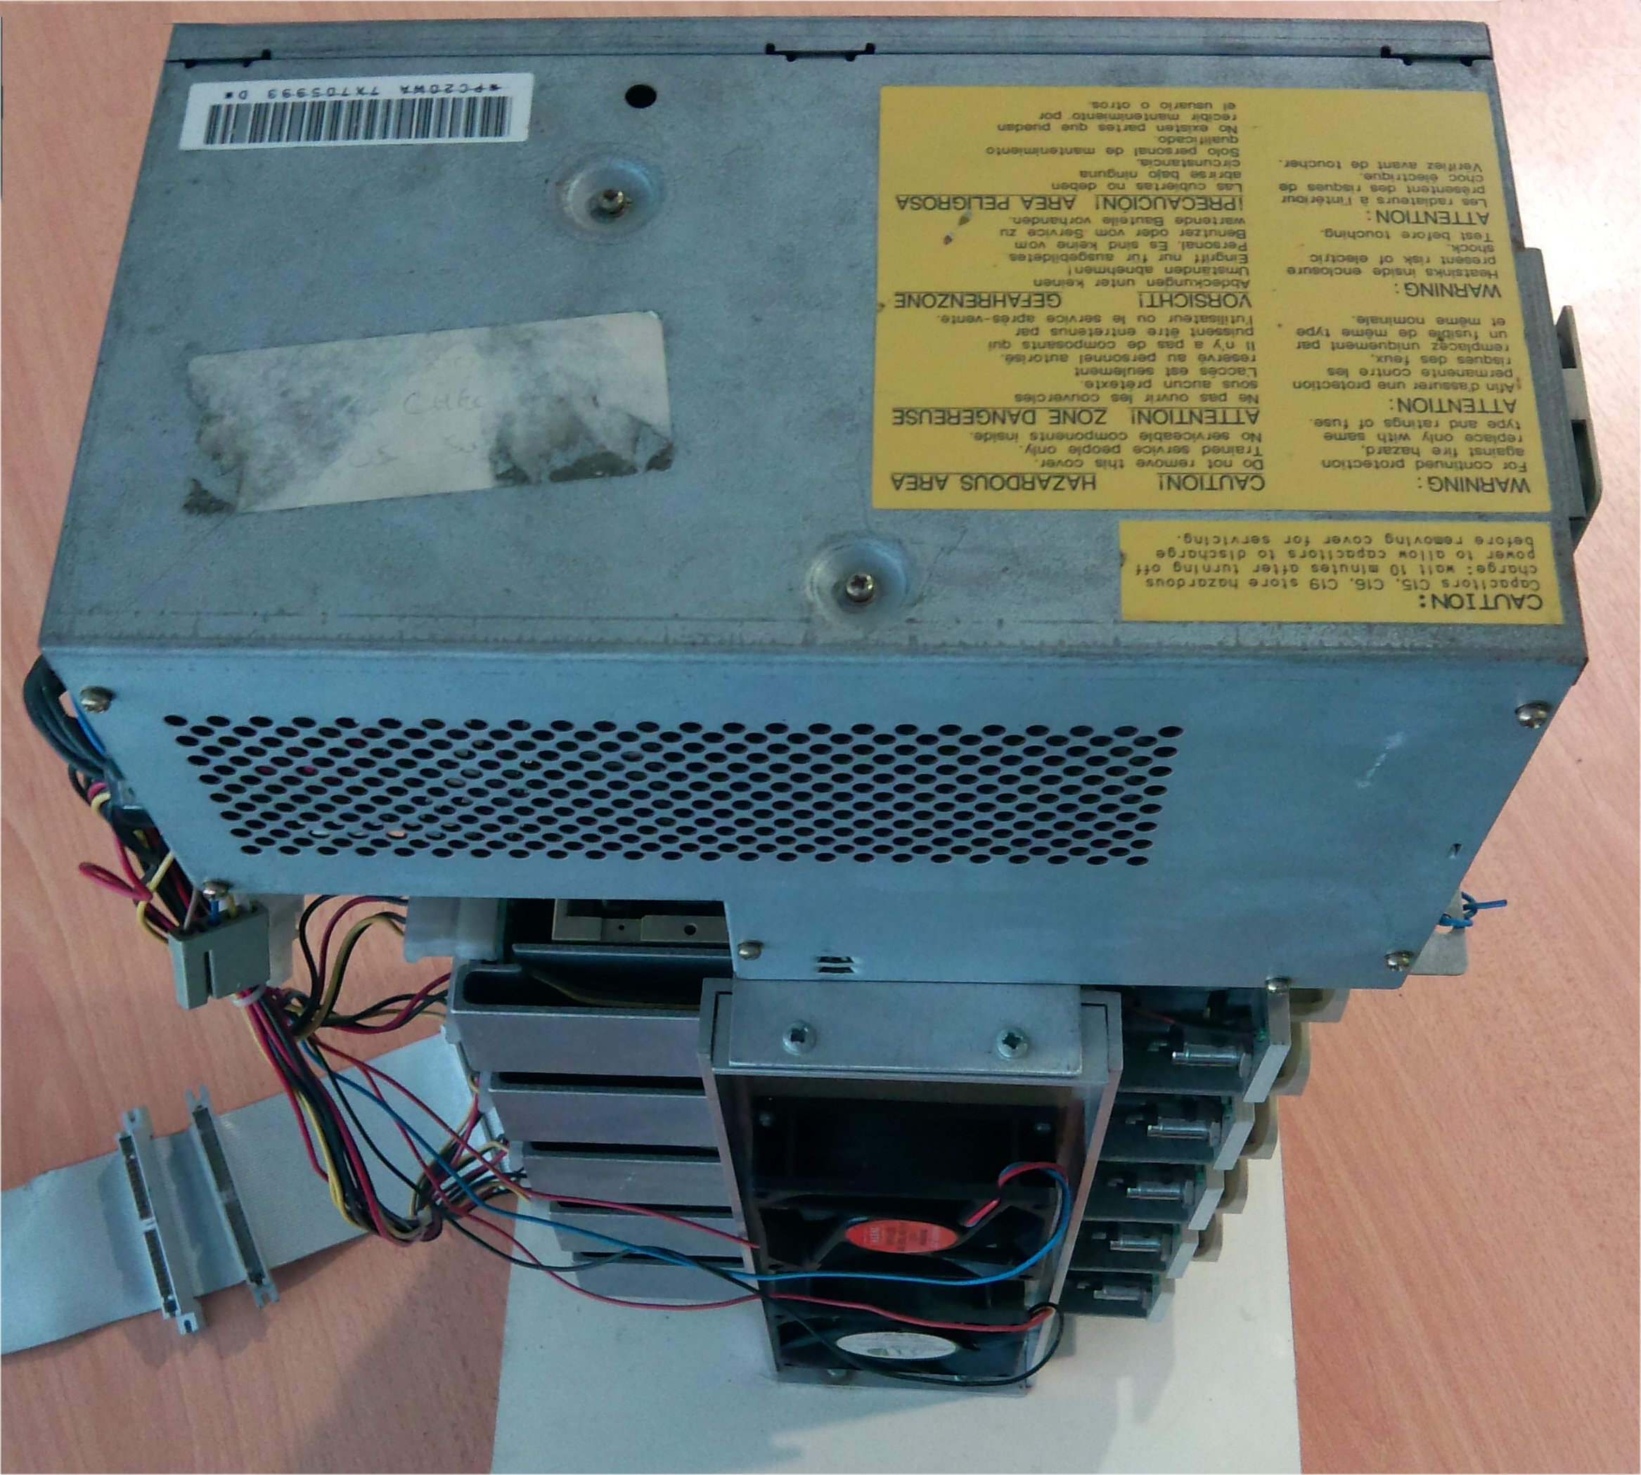
Figure 3: Prototype RAID top side view

