AccessionIndex: TCD-SCSS-T.20150213.009
Accession Date: 13-Feb-2015
Accession By: Prof.Doug Leith
Object name: Apple Macintosh PowerBook 100 portable computer and Floppy Disk Unit
Vintage: c.1991
Synopsis: Low-end Sony redesign from Apple schematics. Powerbook 100 S/N: S02J705J599, Floppy Disk Unit S/N: SA2028AO0581.

Description:
Apple introduced their PowerBook portable computers in Oct-1991. They were early laptops with a trackball rather than a trackpad, and the first to have palmrests in front of the keyboard, now a standard feature of laptops.

The PowerBook 140 and 170 were the original PowerBook designs (see elsewhere in this catalog) while the low-end PowerBook 100 was the result of Apple having sent the schematics of the earlier Macintosh Portable to Sony, who miniaturized the components. Hence the PowerBook 100 design does not match those of the rest of the series, as it was actually designed after the 140 and 170 and further benefited from improvements learned during their development, even though it represented an earlier architecture.

As most of the PowerBook 100 internal components were based on its predecessor, it had a relatively slow Motorola 68HC000 16MHz processor, 2MB memory (but this could be increased to 8MB using an optional expansion card), an inexpensive passive matrix display and only an external floppy disk drive.

The Powerbook 140 was limited to 2MB memory, the 170 to 4MB, so for those for whom physical memory was a priority, the 100 was a useful alternative.

Accession Index | Object with Identification
TCD-SCSS-T.20150213.009.01 | Apple Macintosh Powerbook 140.  S/N: S02J705J599
TCD-SCSS-T.20150213.009.02 | Apple Floppy Disk Unit.  S/N: SA2028AO0581

References:

- Wikipedia: http://www.wikipedia.org/.

Figure 1: Apple Powerbook 100 three-quarter view

Figure 2: Apple Floppy Disk Unit three-quarter view

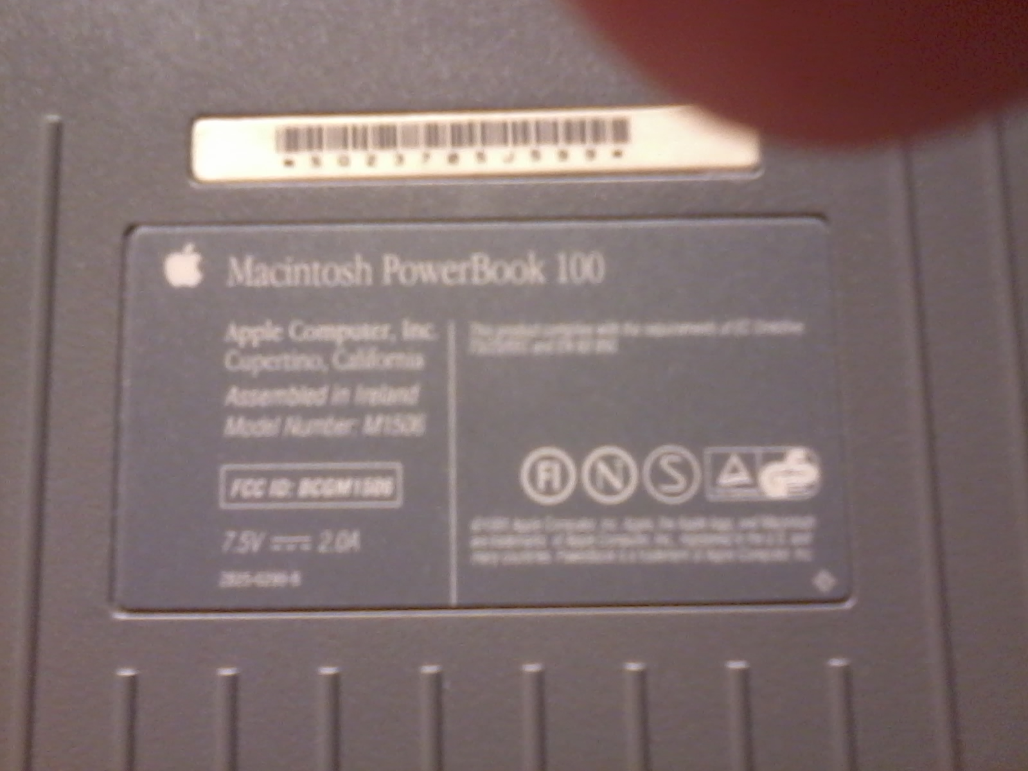
Figure 3: Apple Powerbook 100 manufacturing label

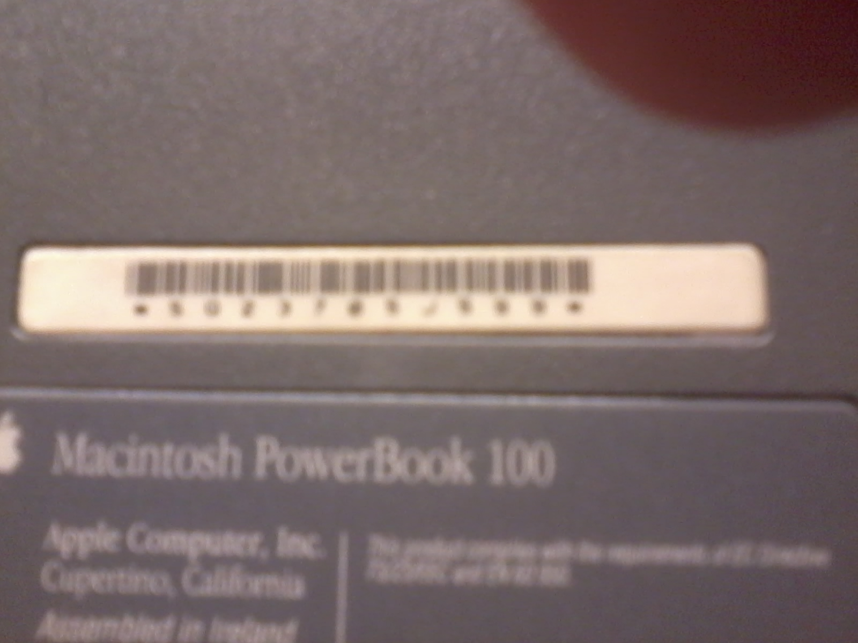
Figure 4: Apple Powerbook 100 serial number

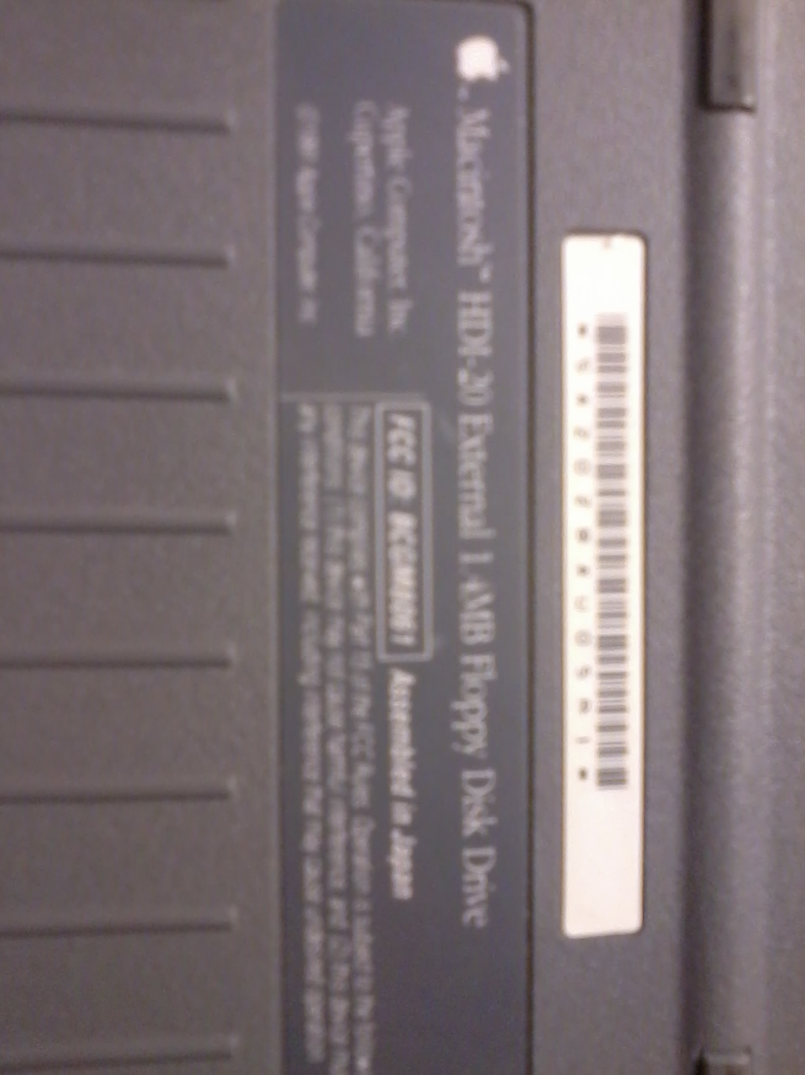
Figure 5: Apple Floppy Disk Unit manufacturing label

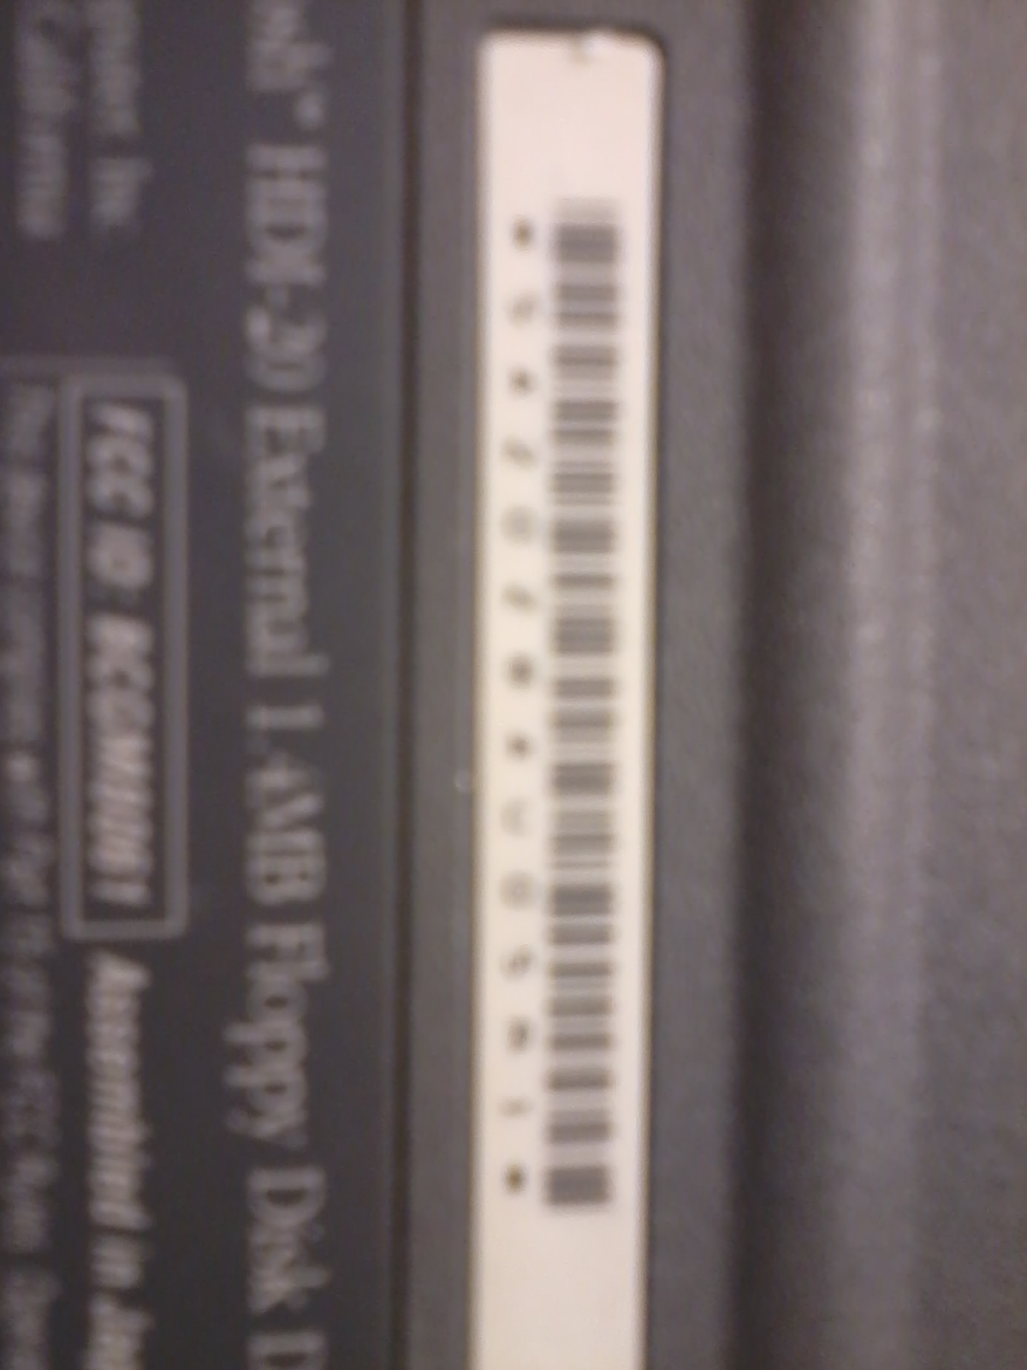
Figure 6: Apple Floppy Disk Unit serial number

