AccessionIndex: TCD-SCSS-T.20150112.006
Accession Date: 12-Jan-2015
Accession By: Prof.Doug Leith
Object name: Atari 400XL
Vintage: 1983
Synopsis: Home game computer. Model: 400U, S/N: BX 078, 050 127044.

Description:
The Atari 400 and 800 were a series of home game computers manufactured by Atari Corporation, first introduced in 1979.

Trivia: The 400 was internally known as "Candy" and the 800 as "Colleen", after two Atari secretaries.

Both the 400 and 800 were based on MOS Technology’s 6502 8bit CPU, 8kB RAM, and two programmable custom ASIC coprocessors (ANTIC and GTIA, principally designed by Jay Miner, Joe Decuir and George McLeod) which provide support for sprites and smooth multidirectional scrolling using direct memory access (DMA), plus another ASIC (POKEY, designed by Doug Neubauer) to provide four channels of audio and serial I/O (via the Atari SIO serial bus). These ASICs made their graphics and sound more advanced than most of their contemporaries. They had two plug-in daughter-boards each holding 8 x 4kx1 RAM, and slot(s) for user-installable cartridge ROMs that included a set of low-level routines for accessing floppy disk drives to boot Atari DOS disk operating system. Atari's SIO bus allowed peripherals to be daisy chained together using an early form of plug-n-play. Each peripherals had its own IDs, and could provide drivers to the Atari 400 or 800 during the boot process. Except for joysticks and an external composite display, all of their functions were integrated into a compact cast aluminium case. The highlight of presentations and demonstrations was Atari's own game Star Raiders.

The 400 was introduced as a child-friendly home games computer with a membrane keyboard resistant to liquid spills. The Atari 400XL, first introduced in 1983, was an improved version of the Atari 400 within approximately the same form factor. Its memory address space was expanded to 64kB, and optional extended RAM or ROM could be bank-switched into this 64kB address space. It replaced the membrane keyboard with a traditional full-travel keyboard.

This item includes a BASIC cartridge 'for use with console keyboard Atari CXL4002'. It also includes documentation and other software, see the Literature category in this catalog.

Many thanks to Professor Doug Leith for donating this item.

The homepage for this catalog is at: https://www.scss.tcd.ie/SCSSTreasuresCatalog/
Click 'Accession Index' (1st column listed) for related folder, or 'About' for further guidance.
Some of the items below may be more properly part of other categories of this catalog, but are listed here for convenience.

Accession Index | Object with Identification
TCD-SCSS-T.20150112.006 | Atari 400XL. Home game computer. Model: 400U, S/N: BX 078, 050 127044. 1983.
TCD-SCSS-T.20241031.002 | Atari ST. Personal computer, S/N: ???? 1985.
TCD-SCSS-V.20121208.473 | Atari User vol.2 no.2 June 1986. 1986.

References:

- Wikipedia, Atari 8-bit computers, see:
https://en.wikipedia.org/wiki/Atari_8-bit_computers
Last browsed to on 2-Nov-2024.

- Wikipedia, Atari 400, see:
https://de.wikipedia.org/wiki/Atari_400
Last browsed to on 2-Nov-2024.

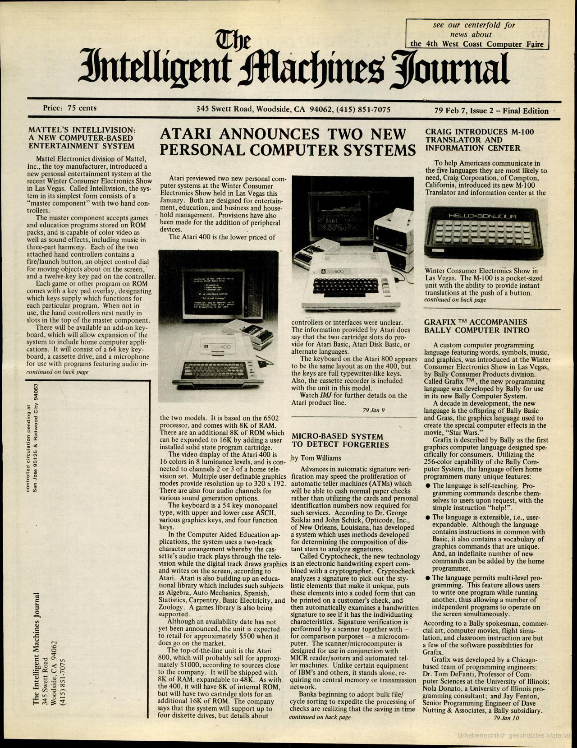
Figure 1: Atari 400XL advertisement, InfoWorld, 7th February 1979.

Figure 1: Atari 400XL.

