AccessionIndex: TCD-SCSS-T.20141120.008
Accession Date: 20-Nov-2014
Accession By: Dr.Brian Coghlan
Object name: DEC DELQA Qbus 10Mbps Ethernet Controller
Vintage: c.1984
Synopsis: DEC DELQA half-width Qbus 10Mbps Ethernet controller board. Markings: 50-17646-01.

Description:
The DEC M-7516 DELQA is a half-width Qbus 10Mbps Ethernet controller board that supports the DEC MicroVAX and LSI-11 families. It connects to the network via a transceiver.

It is MC68000-based, with an AMD Am7990DC/60 LANCE network controller.

It has two other controllers:
QIC: general-purpose Q-bus interface controller (QIC) which provides Q-bus slave control logic, I/O page addressing, DMA arbitration and control.
QNA2: arbitrates requests (R/W access, and DMA) for the DELQA internal bus, which is shared between the QIC, MC68000, and LANCE, as well as arbitration for accesses by the QIC, MC68000 and LANCE, read/write control logic for memory, QIC and LANCE registers, and the DELQA's Control and Status Register (CSR).

It includes 32KB of static RAM for packet buffering, and for scratch use by the MC68000, plus 32KB of Firmware ROM, which also includes diagnostic code. The firmware ROM also contains 4KB of PDP-11 boot/diagnostic code for execution by the host system (Micro VAX systems provide equivalent boot/diagnostic code in their own host system ROM).

The DELQA is programmed via 8-word block commands over the Qbus. It can automatically perform block DMA transfers between host memory and shared RAM on the DELQA.

The DELQA module can automatically implement the maintenance operations protocol (MOP) functions (a subset of DECnet operations) on behalf of a remote console (another node on the Ethernet) without host intervention. A trigger instruction (remote console request to reboot) can be executed if the local host system contains the appropriate BOOT ROM for loading the boot code from the DELQA module. The DELQA module can also automatically process the IEEE 802.2 link-layer service access point (LSAP) null test (loopback) and null XID (transmit ID) messages when used on an IEEE 802.3 local area network.

Accession Index | Object with Identification
TCD-SCSS-T.20141120.008 | DEC DELQA Qbus 10Mbps Ethernet Controller.  Includes:  1 x MC68000FN10  1 x Am7990DC/60 LANCE  1 x Am7992BDC  1 x TC17G014AP-0018  1 x TC17G060AT  1 x TC17G022AT  Markings: 50-17646-01, F1, L1, M7516

See the official DELQA Users Guide EK-DELQA-UG-002.pdf in this folder.

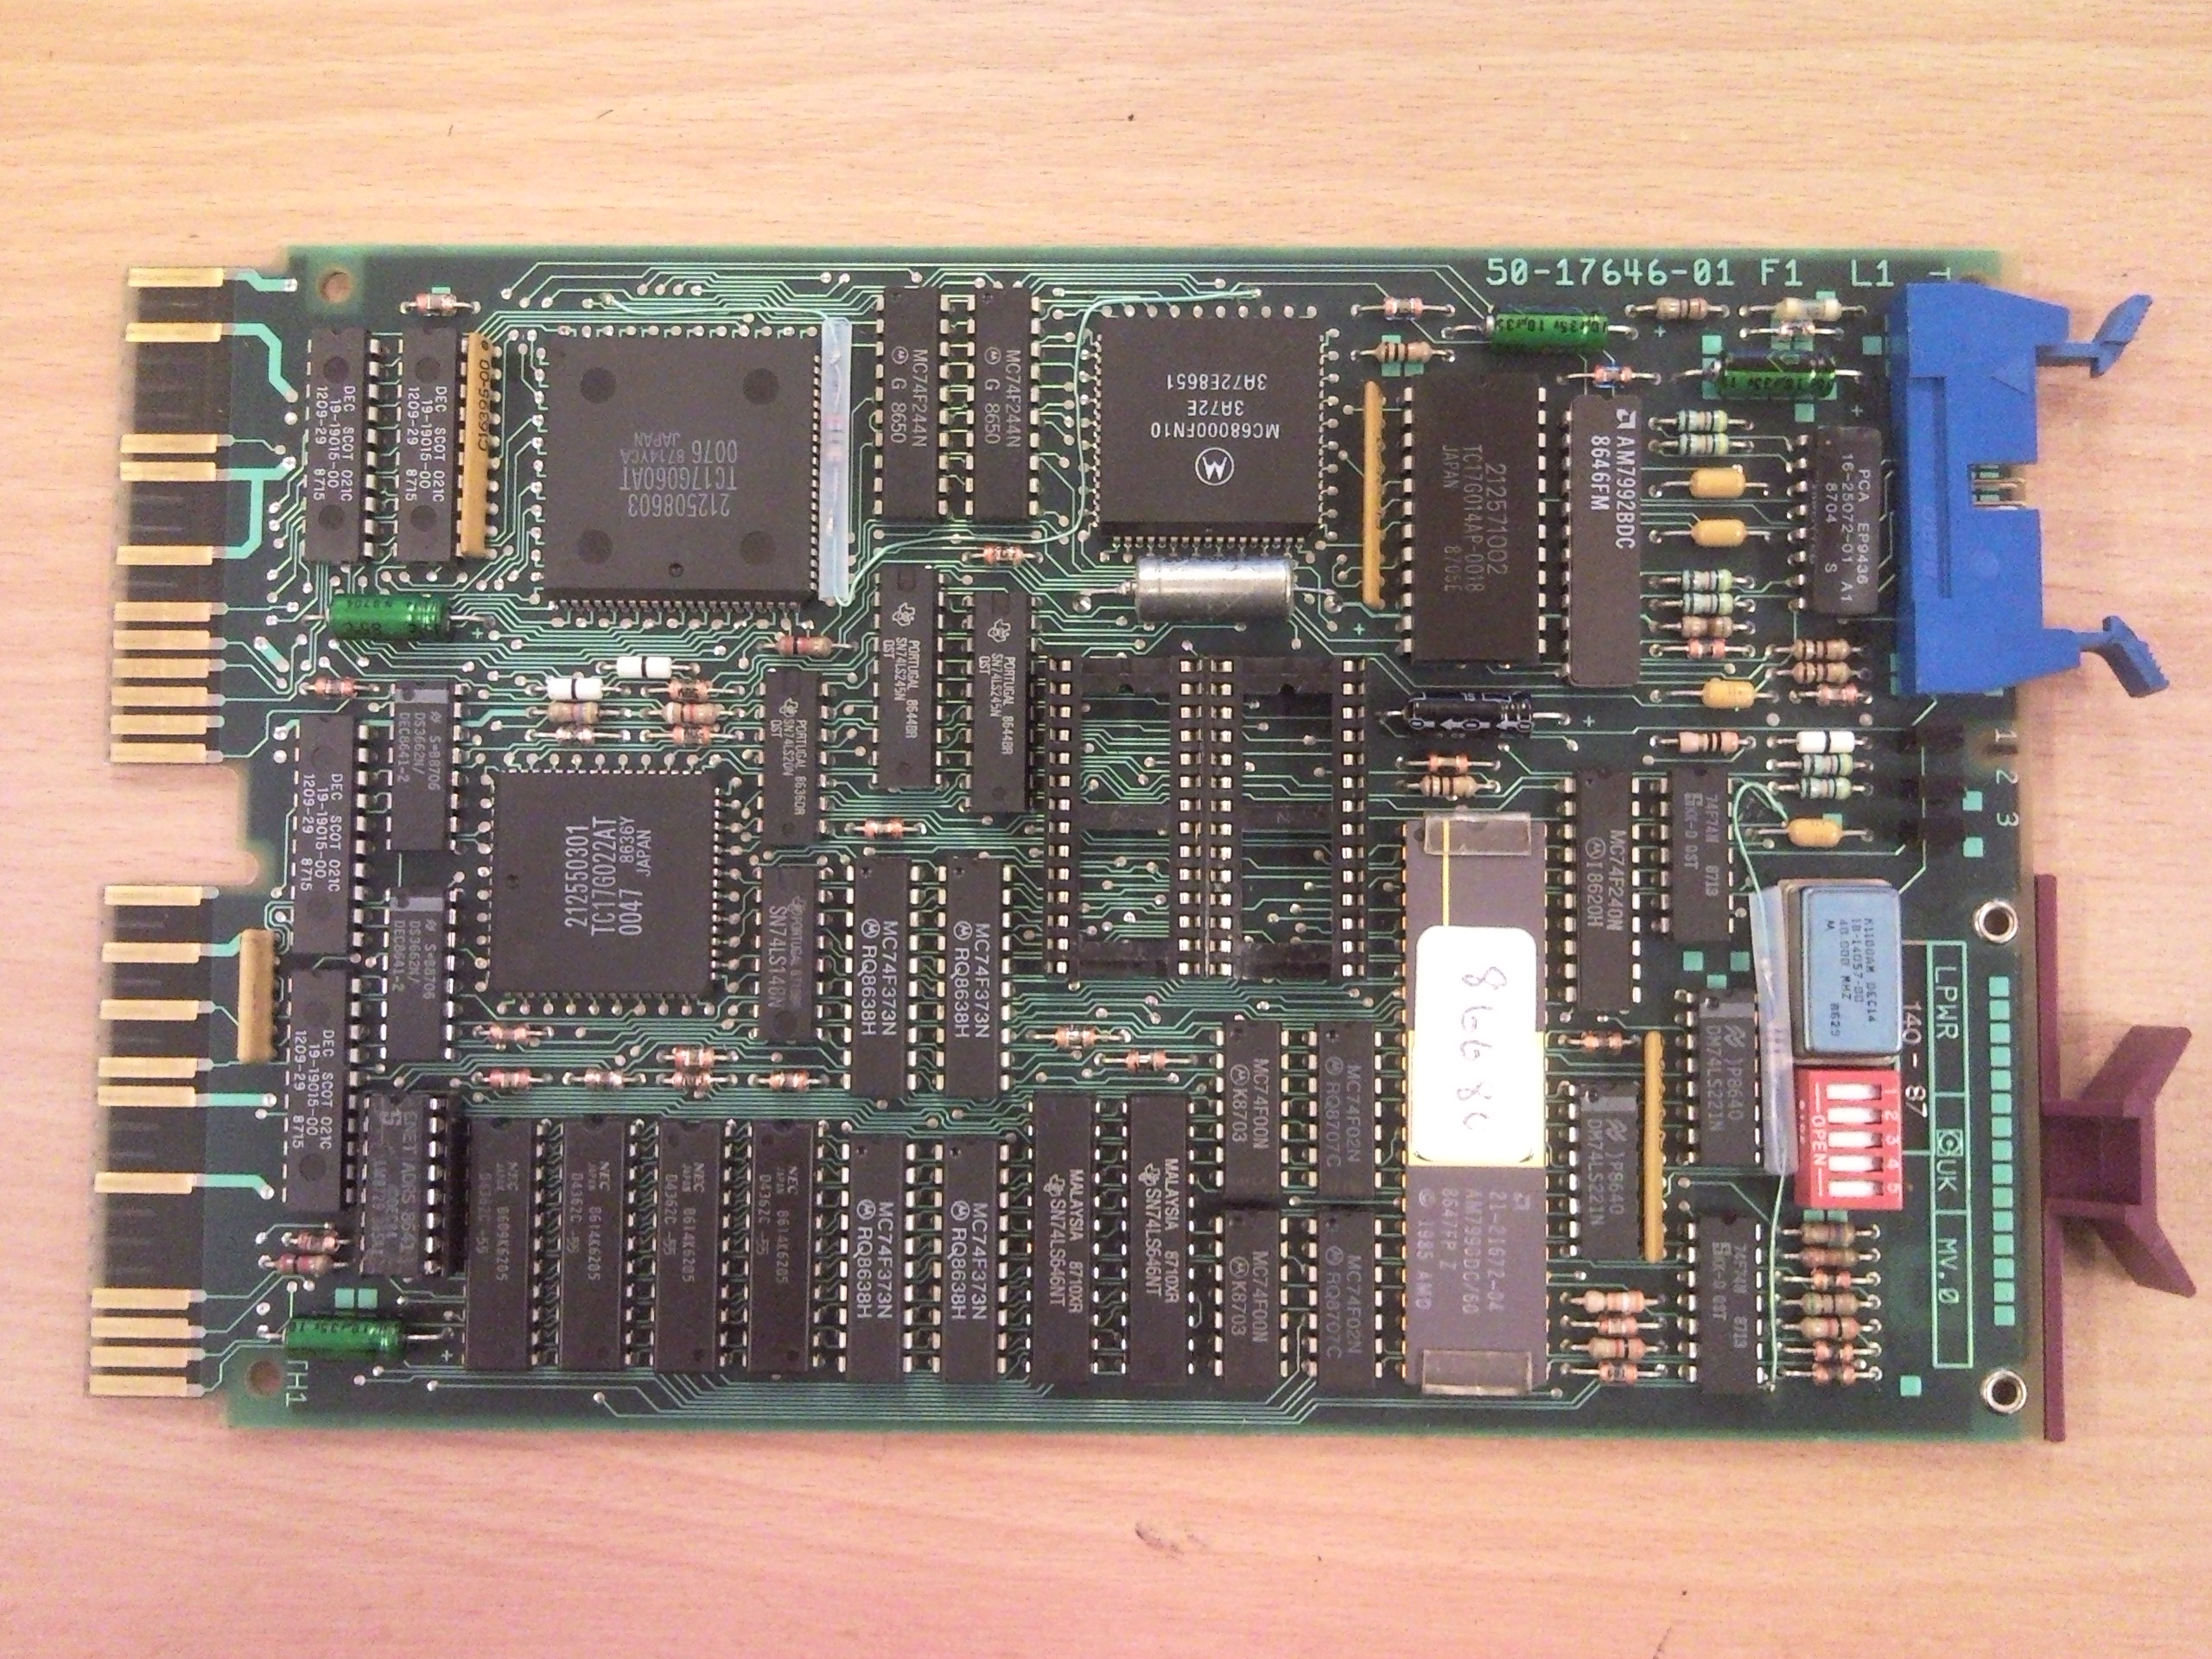Figure 1: DEC DELQA Qbus Ethernet Controller Board

