AccessionIndex: TCD-SCSS-T.20121208.128
Accession Date: 8-Dec-2012
Accession By: Dr.Brian Coghlan, Dr.Michael Stuart
Object name: History of the Department of Statistics, Trinity College Dublin
Vintage: c.1968
Synopsis: The evolution of the Dept.Statistics as reflected in the machines used since its inception.

Description:
The Department of Statistics was established soon after Prof.F.G. (Gordon) Foster was appointed in September, 1967. He served initially as a Visiting Professor during 1967-68 and took up the post permanently in September, 1968. Prior to his arrival Prof.J.G.Byrne, then a lecturer in the Engineering Faculty and subsequently appointed founding Professor of Computer Science in 1972, took the lead in establishing computing within Trinity and subsequently played a leading role in the development of computing in Ireland.

Trivia: March 2018 may mark the 50th anniversary of the formal founding of the Computer Laboratory, the Dept.Computer Science and the Dept.Statistics

Michael Stuart, a long-serving core staff member of the department, has written a history of the department [1], commissioned on behalf of the Irish Statistical Association as a contribution to a history of academic statistics departments in Ireland, to be published in due course (it is expected that suitably presented copies will be published in connection with the Department of Statistics’ 50th anniversary celebration in Nov-2017). From this history:

Gordon came to Trinity from a post as Professor of Computational Methods at the London School of Economics. He brought with him a keen interest in the dissemination and application of statistical and operational research techniques. He had worked extensively in both theory and practical application, starting with a period immediately after graduation from Queen’s University Belfast working on code breaking at Bletchley Park as part of the war effort in the early 1940’s. (In early College documentation, this was enigmatically phrased as “During the war years he worked in the British Foreign Office”). Following completion of his D.Phil. at Magdalen College, Oxford, where his research was strongly influenced by a lecture by Norbert Wiener, he lectured at Manchester University where he met Alan Turing, who introduced him to the Manchester Mark 1 computer, an early stored programme computer.

From this it is evident that on his appointment Prof.Foster already had a keen appreciation of the evolving computing technologies and their theoretical underpinnings, and knew many of the principal personalities.

The early life of the department is best described in the history referred to above, so this description will focus and reflect on the machines used since its inception.

Soon after his arrival, Prof.Foster embarked on a major study of the current state of computing in Ireland, in collaboration with the Department of Finance [2], still an interesting document in relation to computing in that era.

Prof.J.G.Byrne and very importantly Prof.W.Wright (Dean of Engineering) were instrumental in acquiring the early computers in Trinity, first an IBM 1620, followed by an IBM 1130 and subsequently an IBM 360/44, see elsewhere in this collection. The Dept.Statistics was established coincident with the establishment of the Dept.Computer Science and the TCD computing services (known as the Computer Laboratory), and the acquisition of the IBM 360 for the Computer Lab. A computer terminal, connected to the IBM 2848 terminal concentrator of the IBM 360, was installed in the Dept.Statistics (again see elsewhere in this collection for a surviving IBM 2848 acoustic delay line unit).

While still relying heavily on the services of the Computer Laboratory, in 1980 the department gained a degree of independence by installing its own PDP-11 system, funded by the Systems Development Programme (SDP), see Fig.2. This included a terminal dedicated to departmental administration, thus making the department one of the first to have its own computer based administrative system.

The next major computing development within the department was the initiation in 1989 of Project Macintosh, led by Antony Unwin. This initially involved Apple supplying 150 Apple Macs (worth around IR£200,000 at the time) for individual use by undergraduates and relevant staff in the departments of Statistics and Business Studies, along with funding of IR£55,000 provided by Apple and Eolas-Forbairt for a research project into the effects of such a setup on the students involved. Interestingly Dr.Lewis Leith, a lecturer in the Dept.Computer Science, had resigned in c.1980 to establish Apple Ireland, although he was not the key Apple contact for this project.

Prof.Foster retired in 1991, succeeded by Prof.John Haslett. Those of Prof.Foster’s papers that have survived are in the School of Computer Science and Statistics archive space, and eventually may become part of this collection.

In the years prior to retirement, he had been researching a project to improve contact with remote areas in Africa. In the 1990s a Packet-Radio-Email Rig, see elsewhere in this collection, was used by Prof.Foster as part of the EU Trinet Project led by him that used a low-earth-orbiting satellite (LEOSAT) for store-and-forward email communication via amateur packet radio technology and internet email gateways in developed countries, targeted at developing countries in Africa such as Ghana, Uganda, Zambia, and Zimbabwe.

As mentioned above, Michael Stuart has written a short history of the department. In this, Prof.Foster's TriNet project is discussed very briefly on page 9, and there is a section on computing in the department on pages 10-11, with brief reference to the early history and Prof.J.G.Byrne's role.

There were many calculators, personal computers and related hardware in the department over the years but records of these are not readily available, and most would have been discarded over time.

Many thanks to Michael Stuart for his invaluable assistance.
The homepage for this catalog is at: https://www.scss.tcd.ie/SCSSTreasuresCatalog/
Click 'Accession Index' (1st column listed) for related folder, or 'About' for further guidance.
Some of the items below may be more properly part of other categories of this catalog, but are listed here for convenience.

Accession Index | Object with Identification
TCD-SCSS-T.20121208.128 | History of the Department of Statistics, Trinity College Dublin. The evolution of the Dept.Statistics as reflected in the machines used since its inception, c.1968.
TCD-SCSS-T.20121208.086 | Prof.Foster's Packet-Radio-Email Rig: Kenwood TS-790A tri-band transmitter/receiver and Astron RS-20A power supply used for packet radio email to Africa via satellite. TS-790A S//N: 30300023, RS-20A S/N: 91091384, c.199x.
TCD-SCSS-T.20161127.001 | Acoustic delay line unit from IBM 2848: Acoustic delay line unit from the IBM 2848 Display Control for the IBM 2260 Display Stations used with TCD's IBM 360/44, 1964.

References:

- Michael Stuart, The Department of Statistics Trinity College Dublin 1967 - 2017, The Economic & Social Research Institute, final draft, 7th July 2017.

- F.G.Foster assisted by F.Land, J.A.Moynihan, M.G.Tutty, Computers in Ireland, The Economic & Social Research Institute, paper no.58, February 1971, see:
http://www.esri.ie/pubs/GRS58.pdf
Last browsed to on 7-Jul-2017.

Also see the documents stored in the associated folder of this catalog.

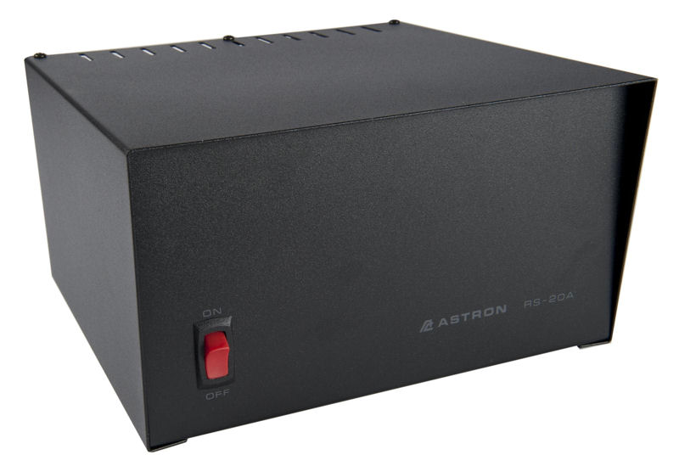
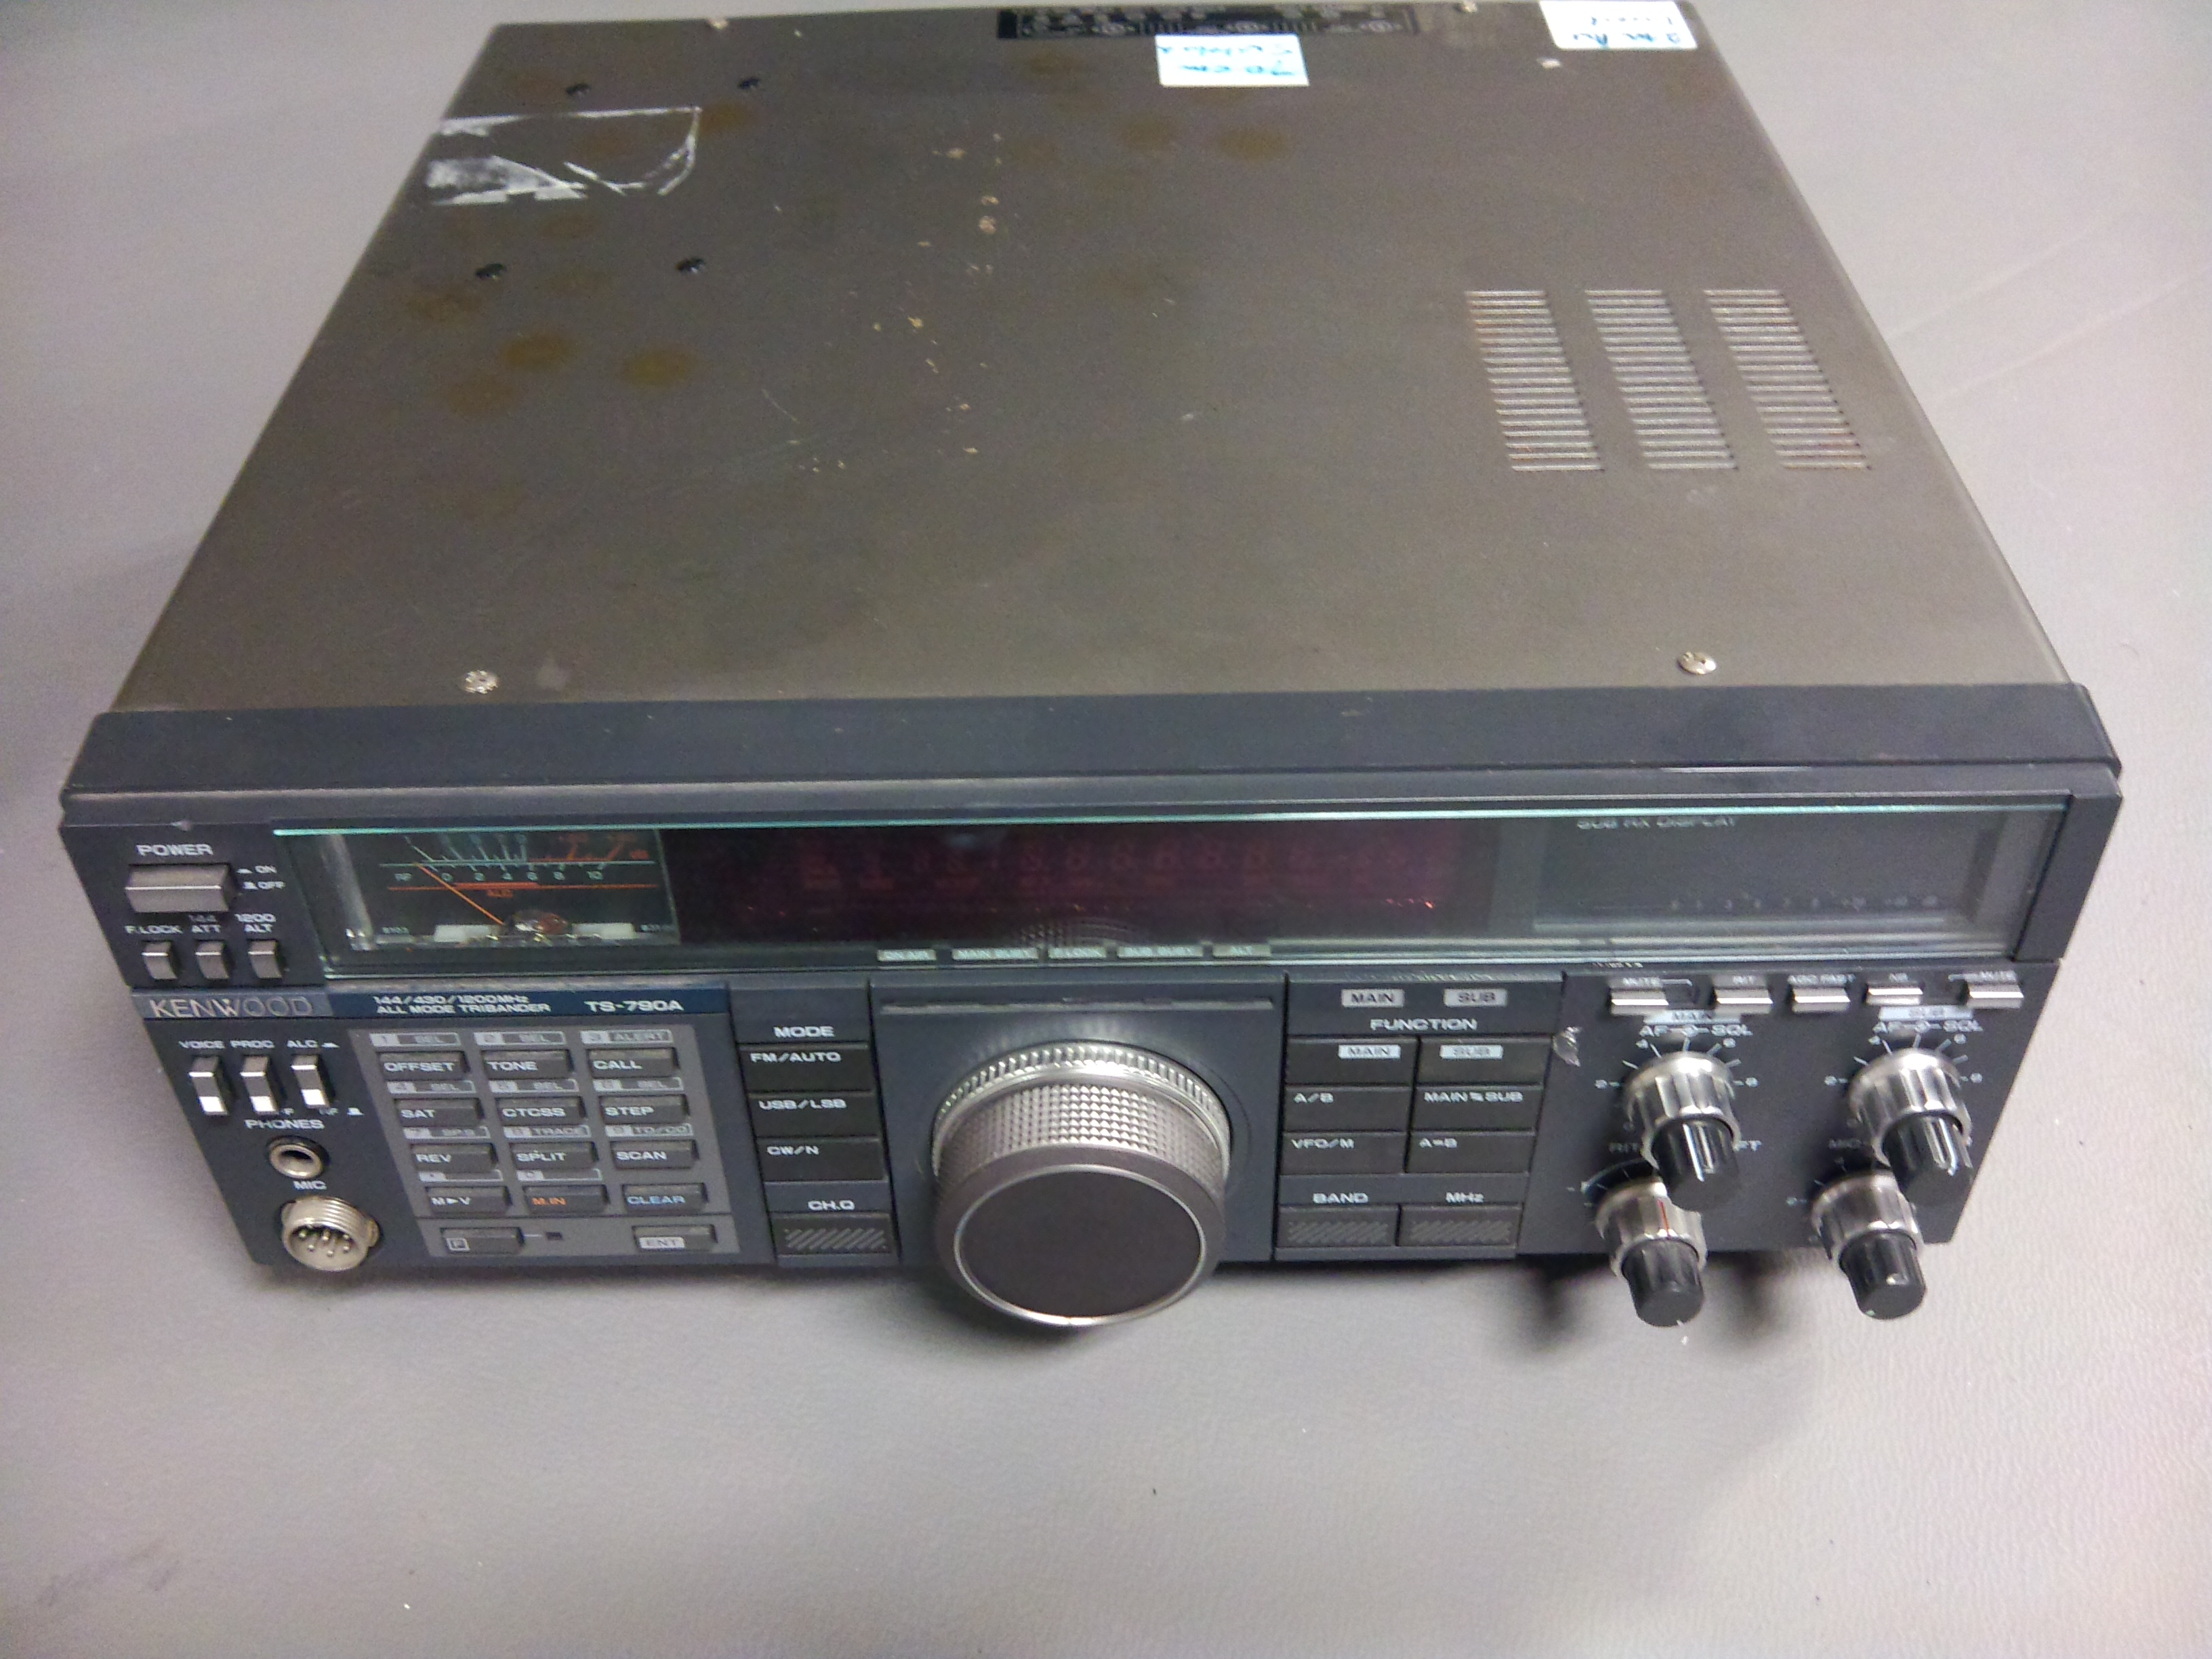
Figure 1: Prof.Foster's Packet-Radio-Email Rig
Upper: Power Supply
Lower: Transceiver

Figure 2: Invoice for PDP-11 purchased in 1980 by Dept.Statistics
Courtesy Dr.Michael Stuart

