AccessionIndex: TCD-SCSS-T.20121208.122
Accession Date: 8-Dec-2012
Accession By: Prof.J.G.Byrne
Object name: Cebar CD330-8ML Calculator
Vintage: c.19xx
Synopsis: Cebar CD330-8ML Calculator. S/N: ???.

Description:
Text …

Accession Index | Object with Identification
TCD-SCSS-T.20121208.122.001 | Cebar CD330-8ML Calculator.  S/N:

References:

- Wikipedia, Xxxxxxx, see (last browsed to xx-yyy-20zz):
https://en.wikipedia.org/wiki/Xxxxxxx

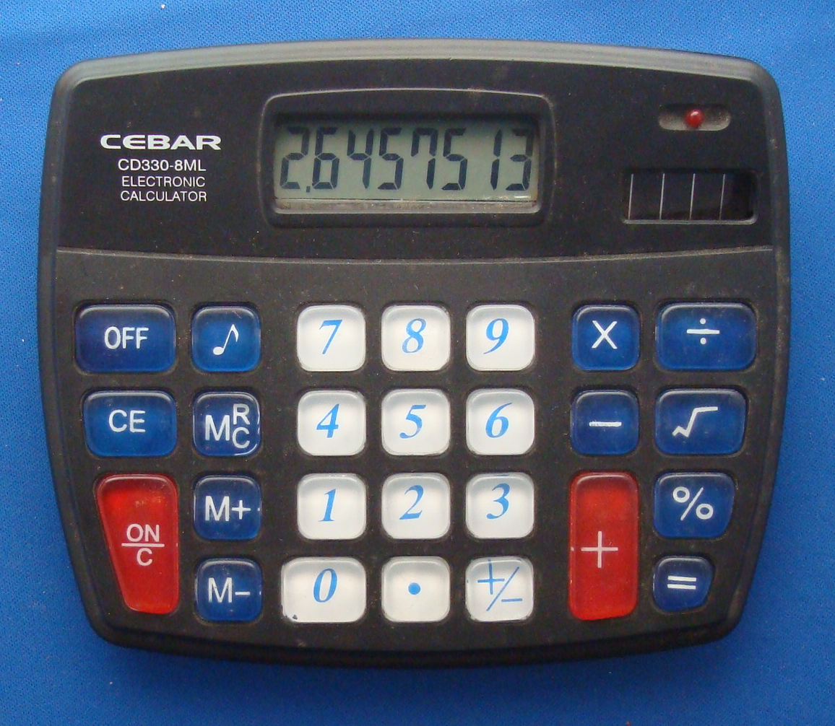
Figure 1: Cebar CD330-8ML Calculator front view

