AccessionIndex: TCD-SCSS-T.20121208.117
Accession Date: 8-Dec-2012
Accession By: Prof.J.G.Byrne
Object name: Seiko YJ32 World Time Rate Exchanger
Vintage: c.19xx
Synopsis: Seiko YJ32 World Time Rate Exchanger. S/N: ???.

Description:
Text …

Accession Index | Object with Identification
TCD-SCSS-T.20121208.117.001 | Seiko YJ32 World Time Rate Exchanger.  S/N:

References:

- Wikipedia, Xxxxxxx, see (last browsed to xx-yyy-20zz):
https://en.wikipedia.org/wiki/Xxxxxxx

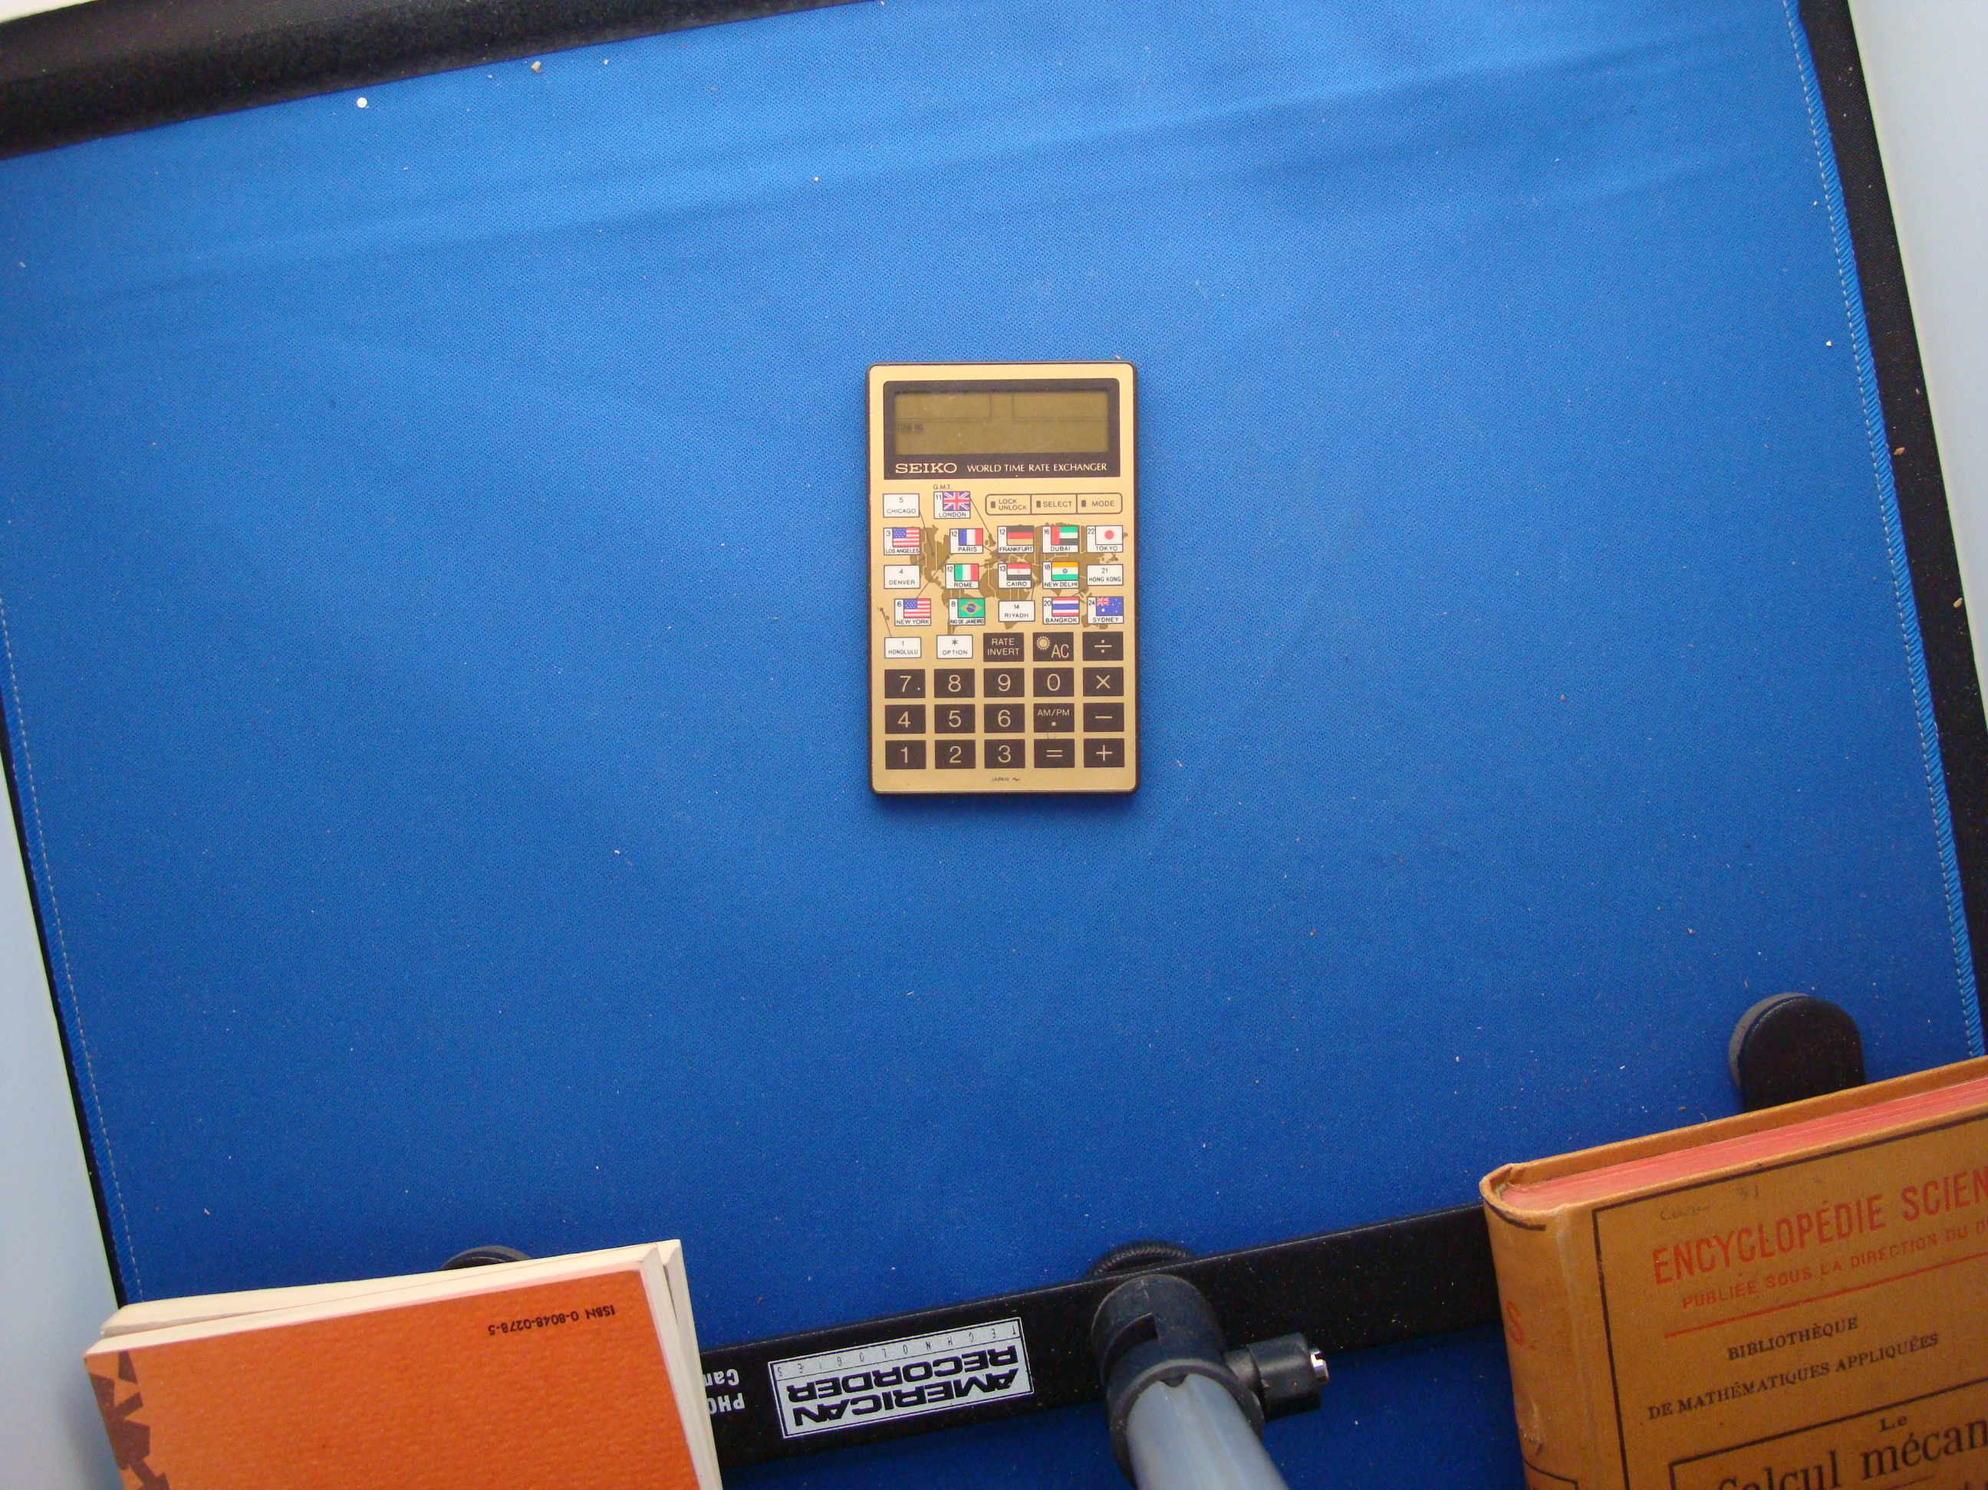
Figure 1: Seiko YJ32 World Time Rate Exchanger front view

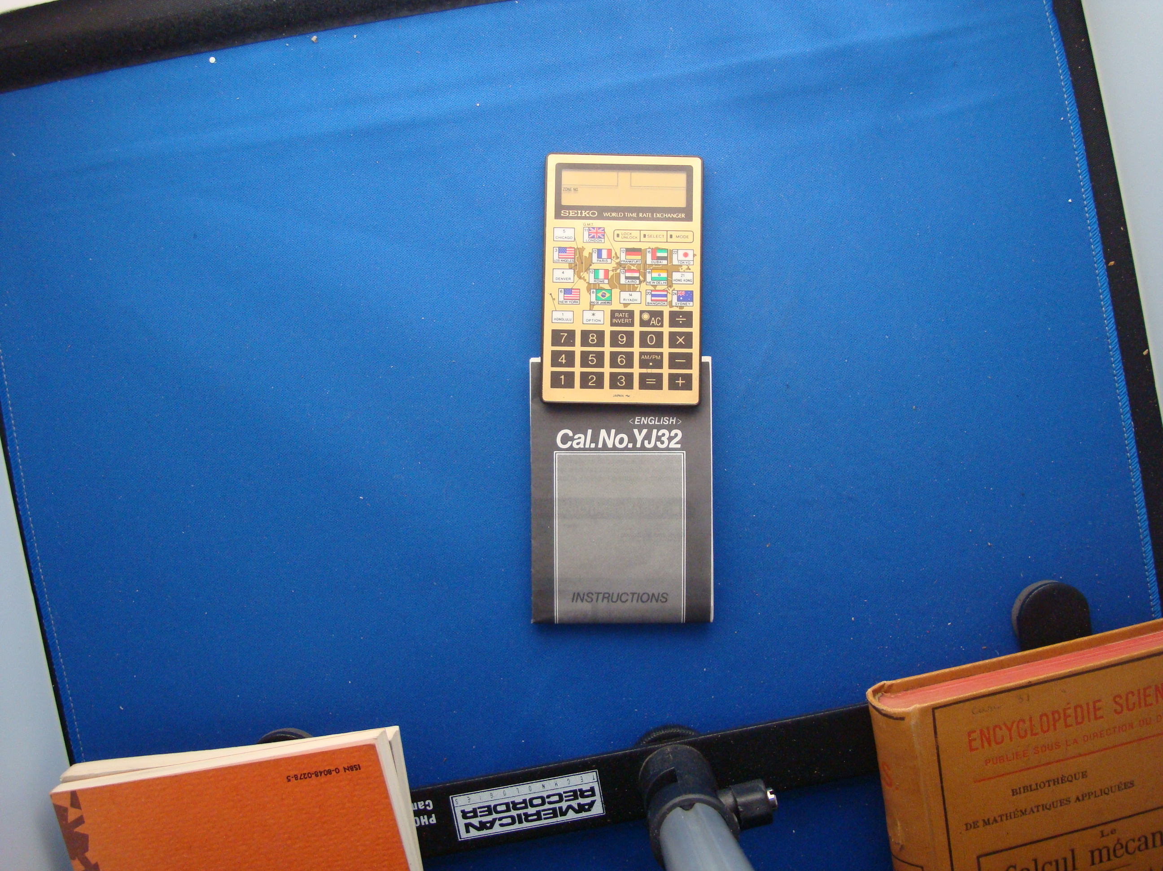
Figure 2: Seiko YJ32 World Time Rate Exchanger and Instruction Manual front view

