AccessionIndex: TCD-SCSS-T.20121208.090
Accession Date:
Accession By:
Object name: Apollo DN10000
Vintage: c.1988
Synopsis: Minisupercomputer, with PRISM multi-chip CPU. S/N: ???.

Description:
The Apollo DN10000 was a minisupercomputer, among the fastest of its peers at the time. Its multi-chip CPU incorporated Apollo’s PRISM architecture. Up to four CPUs could be installed.

The PRISM architecture was a forerunner of VLIW architectures, which expose multiple CPU functional units as part of their programming model. The expectation is that their compilers will focus on exploiting parallelism while avoiding inconsistent usage of these units. The PRISM architecture exposed just two units: a 32-bit integer unit and a 32/64-bit floating-point unit, so it was ‘LIW’ rather than VLIW. For its time it was unusual in integrating multiply-and-add/subtract instructions.

At the time a major architectural focus was on RISC developments, so the DN10000 and competitors like Multiflow’s TRACE VLIW minisupercomputer (based on Josh Fisher’s trace scheduling work at Yale University), and Intel’s (less successful) ‘LIW’ i860 CPU (based on early joint work with Apollo), were notable departures.

Apollo products typically connected to their proprietary 12Mbps token-ring network (which scaled better than 10Mbps Ethernet but failed if any connected node failed), and ran Apollo’s proprietary UNIX-like Domain/OS, which exploited the token-ring network and natively implemented distributed shared memory.

When Apollo was taken over by Hewlett Packard in 1989 the DN10000 was discontinued, but the some of its features were inherited by both the HP PA-RISC and Intel/HP Itanium architectures. HP also inherited Josh Fisher when he joined HP upon Multiflow's demise.

The Dept.Computer Science at TCD purchased a DN10000 server and three DN3550 workstations from BIC Systems in Belfast in 1989. The DN10000 had 32MB of memory and 2.1GB of disk, and ran the Domain/OS operating system. Unusually, it was connected to Ethernet rather than token-ring. Both it and the workstations were used with the Mentor Graphics CAD package.

Apollo DN10000. S/N: ???.

trivia1: PRISM = Parallel Reduced Instruction Set Machine.
trivia2: given design, appropriately named 'wilde.cs.tcd.ie'

The homepage for this catalog is at: https://www.scss.tcd.ie/SCSSTreasuresCatalog/
Click 'Accession Index' (1st column listed) for related folder, or 'About' for further guidance. Some of the items below may be more properly part of other categories of this catalog, but are listed here for convenience.

Accession Index | Object with Identification
TCD-SCSS-T.20121208.090 | Apollo DN10000. Minisupercomputer, with PRISM multi-chip CPU.  S/N: ???, c.1988.

References:

- Wikipedia: http://en.wikipedia.org/wiki/Apollo_PRISM

- Nickolai Zeldovich’s Apollo webpage: http://www.zepa.net/apollo/

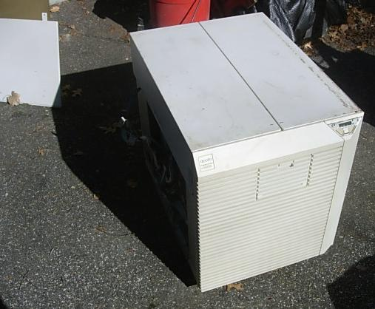
Figure 1: Apollo DN10000 three-quarter view
https://legalizeadulthood.wordpress.com/2008/04/30/tektronix-4010-4051-and-4114-and-apollo-dn10000-join-the-collection/

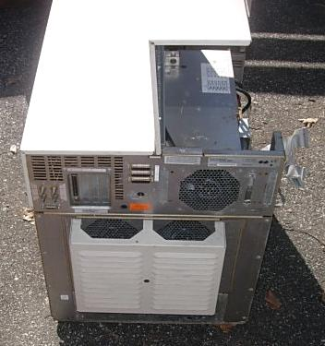
Figure 2: Apollo DN10000 rear view
https://legalizeadulthood.wordpress.com/2008/04/30/tektronix-4010-4051-and-4114-and-apollo-dn10000-join-the-collection/

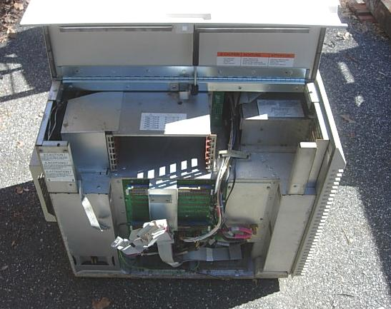
Figure 3: Apollo DN10000 left-side view
https://legalizeadulthood.wordpress.com/2008/04/30/tektronix-4010-4051-and-4114-and-apollo-dn10000-join-the-collection/

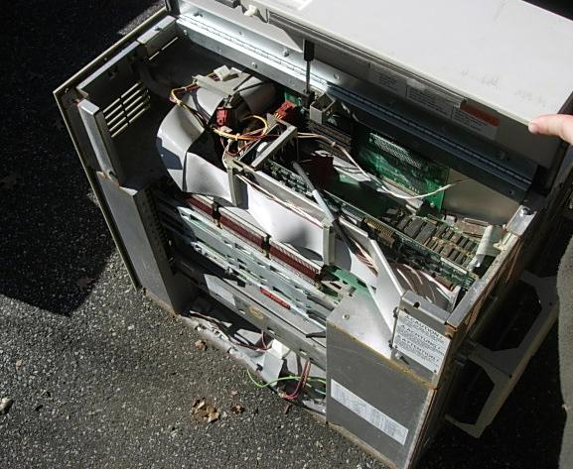
Figure 4: Apollo DN10000 right-side view
https://legalizeadulthood.wordpress.com/2008/04/30/tektronix-4010-4051-and-4114-and-apollo-dn10000-join-the-collection/

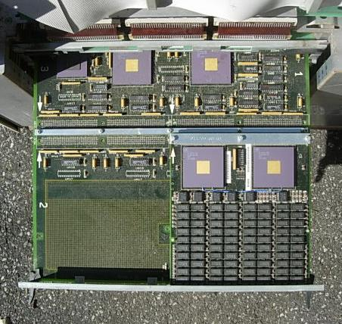
Figure 5: Apollo DN10000 board 1
https://legalizeadulthood.wordpress.com/2008/04/30/tektronix-4010-4051-and-4114-and-apollo-dn10000-join-the-collection/

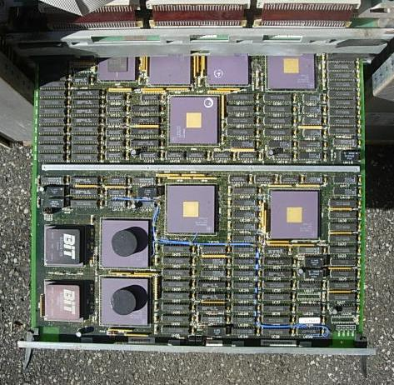
Figure 6: Apollo DN10000 board 2
https://legalizeadulthood.wordpress.com/2008/04/30/tektronix-4010-4051-and-4114-and-apollo-dn10000-join-the-collection/

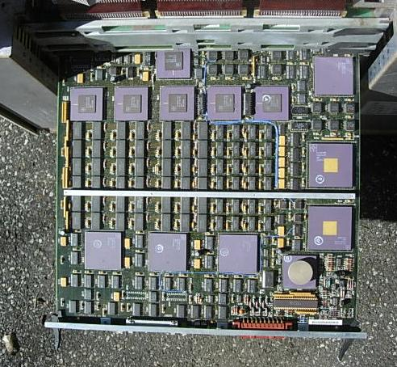
Figure 7: Apollo DN10000 board 3
https://legalizeadulthood.wordpress.com/2008/04/30/tektronix-4010-4051-and-4114-and-apollo-dn10000-join-the-collection/

