AccessionIndex: TCD-SCSS-T.20121208.010
Accession Date: 8-Dec-2012
Accession By: Prof.J.G.Byrne
Object name: Plus 509 Adder
Vintage: c.195x
Synopsis: Quinary mechanical adding machine with 'half keyboard'.

Description:
A quinary mechanical adding machine, with 9-digit addend and 10-digit total, with 'half keyboard' that has only 5 keys per digit, '1' to '5' (larger numbers need two additions, e.g. 777 = 555 + 222), made by Bell Punch Co. Ltd. in Britain, distributed by Sumlock Ltd, both owned by Control Systems Ltd. This 'plus adder' was used by the Totalizer Board in Ireland to work out dividends from betting at horse races.

The homepage for this catalog is at: https://www.scss.tcd.ie/SCSSTreasuresCatalog/
Click 'Accession Index' (1st column listed) for related folder, or 'About' for further guidance. Some of the items below may be more properly part of other categories of this catalog, but are listed here for convenience.

Accession Index | Object and Identification
TCD-SCSS-T.20121208.010 | Plus 509 Adder, Quinary mechanical adding machine with 'half keyboard', c.195x.  S/N: 509/LD/885651.
TCD-SCSS-T.20121208.001 | Lightning Calculator, 7-digit decimal mechanical adding machine with rotary input dials, c.1908.
TCD-SCSS-T.20121208.002 | Brunsviga Adding Machine, Decimal pin-wheel mechanical adder/subtractor (pincalculator), c.1913.  S/N: 6214, Markings: AGS No.50
TCD-SCSS-T.20121208.003 | Master Adding Machine, 9-digit decimal mechanical adding machine, c.192x.
TCD-SCSS-T.20121208.004 | Brunsviga 13RK Adding Machine, Decimal pin-wheel mechanical adding machine (pincalculator) , c.195x.
TCD-SCSS-T.20121208.005 | ADDO Model 9 Sterling Calculator, 8-digit mechanical £-s-d (Sterling) adder/subtractor, c.1927.
TCD-SCSS-T.20121208.006 | R.C.Allen Model 8s Sterling Calculator, 8-digit mechanical £-s-d (Sterling) adder/subtractor, c.193x.
TCD-SCSS-T.20121208.007 | Burroughs T890-9 Protectograph, Bank cheque embosser, c.195x.
TCD-SCSS-T.20121208.008 | Facit TK Calculator, Hand-cranked 13-digit decimal mechanical calculator. S/N: 202895, c.1936.
TCD-SCSS-T.20121208.009 | Facit NEA Calculator, Electrical motor-driven 13-digit decimal mechanical calculator. S/N: 273356, c.1943.
TCD-SCSS-T.20121208.012 | MADAS Portable Calculator, Model 20BTZG 10-digit fully-automatic decimal mechanical calculator. S/N: 96236, c.196x.

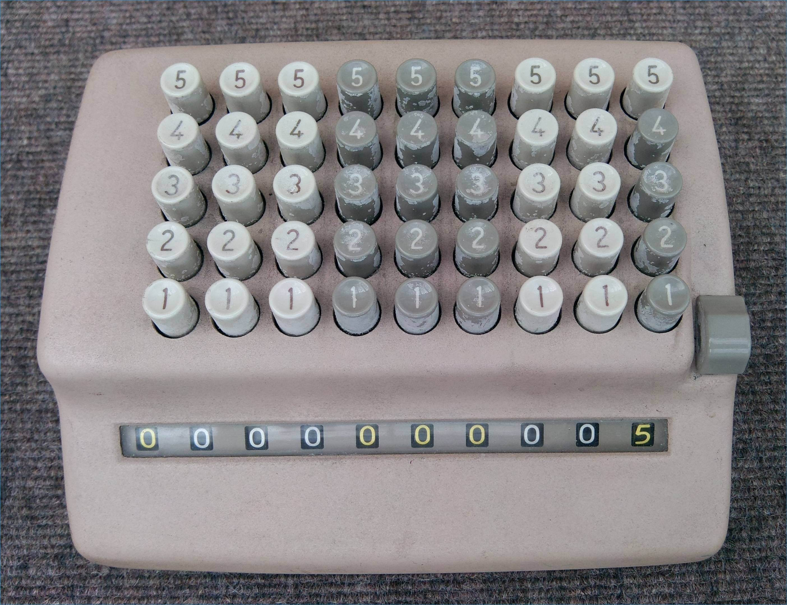
Figure 1: Plus 509 Adder top view

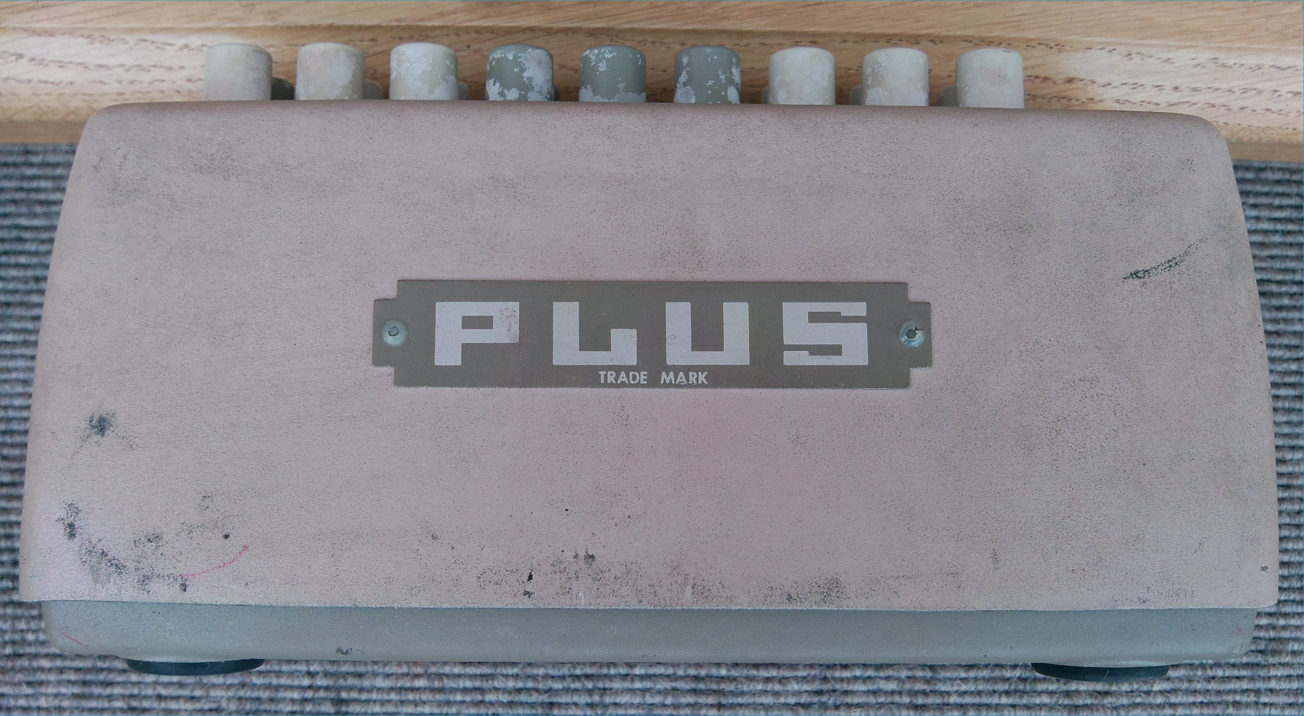
Figure 2: Plus 509 Adder front view

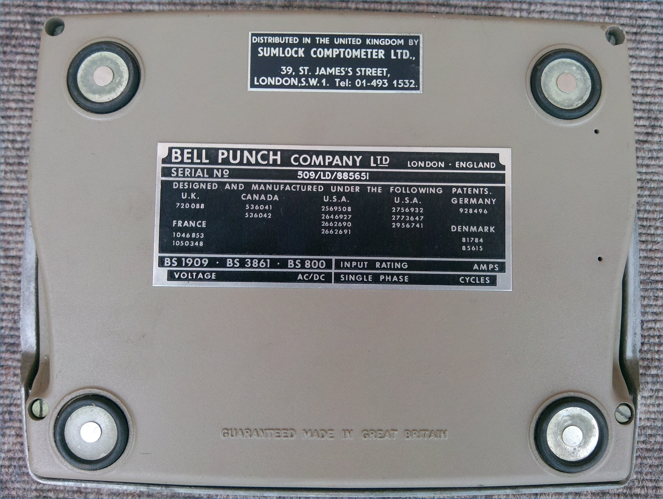
Figure 3: Plus 509 Adder bottom view

Figure 3: Plus 509 Adder manufacturing labels
S/N: 509/LD/885651

